**Medical Informatics**

**(Assignment Medical Images Processing)**

**Ahmed Samir Afifi**

**----------------------------------------------------------**

**احمد سمير عفيفي**

Dr/ Hala Zayed

Eng. Nada Bahaa

2020/2021

**Step 1:**

import numpy as np

import matplotlib.pyplot as plt

import cv2

from PIL import Image

image = np.array(Image.open('CT_Spine.png'))

gray = cv2.cvtColor(image,cv2.COLOR_BGR2GRAY)

plt.Figure()

plt.hist(gray)

**RUN:**

(array([[213., 0., 0., ..., 0., 0., 0.],

[213., 0., 0., ..., 0., 0., 0.],

[213., 0., 0., ..., 0., 0., 0.],

...,

[213., 0., 0., ..., 0., 0., 0.],

[213., 0., 0., ..., 0., 0., 0.],

[213., 0., 0., ..., 0., 0., 0.]]),

array([ 0. , 25.4, 50.8, 76.2, 101.6, 127. , 152.4, 177.8, 203.2,

228.6, 254. ]),

<a list of 179 BarContainer objects>)

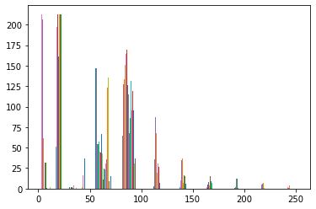

T, threshold = cv2.threshold(gray,0,255,cv2.THRESH_OTSU)

plt.gray()

plt.imshow(threshold)

**RUN:**

<matplotlib.image.AxesImage at 0x2b5df80c190>

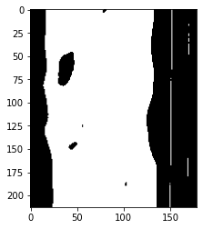

T, threshold1= cv2.threshold(gray,120,255,cv2.THRESH_BINARY)

plt.gray()

plt.imshow(threshold1)

**RUN:**

<matplotlib.image.AxesImage at 0x2b5df566760>

